**CIS-481: Introduction to Information Security**

**Module 1 - Introduction to Information Security**

**Exercise #1**

**Team:**

**Participants: Darrell Liwanag**

**Logistics**

1. Get together with other students on your assigned **Team** in person and/or virtually.
2. Discuss and complete this assignment in a collaborative manner. Don’t just assign different problems to each teammate as that defeats the purpose of team-based learning and may impact your performance on assessments, especially with respect to the essay questions.
3. Choose a scribe to prepare a final document to submit via Blackboard for grading, changing the file name provided to denote the number of your assigned **Team**.

**Problem 1** *(8 points)*

The CIA triad presents three essential characteristics of information that must be protected. However, most agree that these three characteristics are not the only ones that need to be protected. Other characteristics include *authenticity*, *accuracy*, *possession*, *timeliness*, and *utility*.   
If you were tasked with expanding it into an information security *rectangle* instead by adding a single additional characteristic of information, which would you choose and why?

If I were to add to the triangle to create a rectangle, I would choose timeliness as the additional characteristic of information. This is due to the fact that information is always evolving, new pieces of information pop up each day and its important to stay ahead of the curve. Having timeliness compliments the other 3 characteristics because timeliness of information can effect the availability and confidentiality of information.

**Problem 2** *(9 points)*

In 1991, John McCumber proposed a model for Information Security that uses a 3-D cube, as below. Describe each of the three dimensions of the McCumber Cube and comment on the interaction of the three specific sub-components in one of the 27 cells within the Cube.

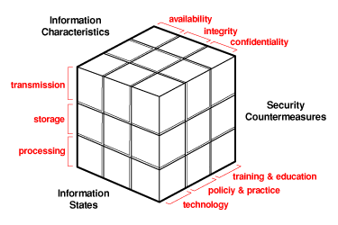

The First Dimension Which is Confidentiality, integrity, and availability describes the characteristics of information which means each component represents a fundamental objective in info security.

The Second dimension is storage, processing and transmission which describes the state of the information whether its at rest or in a database or if its being processed in the cpu and if its being relayed in the network

The final dimension is technology, policy & practice, and training & education which describes how the other two dimensions will be controlled whether its through having a technological control, policy and practice or education.

Each point describes how each subject intersects with another dimension for example, how education can interact with the confidentiality of information that is at rest in storage.

**Problem 3** *(8 points)*

How can the practice of information security be described as both an *art* and a *science*? How does security as a *social science* influence its practice?

Information Security is an art and a science because when it comes to building and making security systems it takes expertise, time, creativity and patience. These are all qualities that are needed to create art. Art can take its form on to many forms of media just as there is art to war. There is art in Whitehat hacking and other forms of info sec. Its science in the fact that there are known knowns and known unknowns. Info security is a studied subject that requires experimentation to get correctly. With it being studied and experimented with it qualifies itself as a science.